SAMPLE SUMMER MENU
entrees served with fresh breads with spreads, house salad

Appetizers
cheese plate 12. veg
Jone’s Family Farm Goat cheese + Marcona Almonds & honeycomb
‘Three Villages’ Tomme + blistered grape tomato & capers
Moody Blue smoked bleu cheese + onion marmalade
Cahill’s Irish Whiskey Cheddar – gingered green apple

Beardslee greens 8.50
…our riff on Utica greens, more crunch, more flavor
escarole, cappicola, garden fresh peppers, garlic,
parmesan & buttered breadcrumbs, grilled house focaccia

grilled rabbit sausage 9.
castelvetrano olive, preserved lemon,
peppadew, & figs, cider sausage jus

roast-cauliflower gnocchi 8.50 veg
brown butter, sage, cured olive, Brussels leaves,
toasted macadamia, shredded Tre Villaggio cheese

peaches & cream 8. veg
grilled fresh peach, Maplebrook Farms burrata cheese
dried mango, arugula, orange vincotto

‘Caprese’ salad 9. veg
heirloom tomato medley & basil marinated buffalo mozzarella
applewood- smoked sea salt, kalamata, cracked black pepper

fried breaded cheese ravioli 7.75 veg
house marinara, red bell pepper cream, shredded parmesan

grilled mushroom-pepper bruschetta 8.75 veg
portabella, Italian long hot pepper, caramelized onion, gorgonzola bleu, grilled house focaccia, balsamic drizzle

Louisiana ‘gator cake 10.
gator tenderloin with onion, celery, carrot, red pepper, black bean, corn, with cumin remoulade

eggplant fritters 8.75 veg
thin breaded eggplant layered with sundried tomato pesto, roasted red bell peppers & goat cheese, with 3 savory sauces

beets ‘n goat 9. veg
fresh red beets simmered in balsamic honey , greens,
Jones Family Farm goat cheese, shaved fennel,
grilled red onion, walnuts, balsamic drizzle

“Duck Trap” smoked Maine trout 9.75
cucumber carpaccio, Hawaiian black sea salt
orange-tomato relish, lime oil

Castle calamari 9.
lightly breaded, tossed with hot peppers,
orange ginger garlic sauce, crisp daikon & cilantro

baked onion soup 7.50
garlic crouton, melted Gruyere Swiss, parmesan, smoked paprika

pan blackened tofu salad 8. vegan
lemon wasabi vinaigrette, pickled daikon, pickled ginger, arugula, savoy cabbage, roasted peanuts, crispy onion

Brussels sprouts 8.50
pan caramelized with prosciutto,
tangy lemon caper dressing, toasted walnuts

agé tofu 7.50 vegan
sesame dusted flash fried tofu cubes
wasabi, pickled ginger, garlic soy sauce

grilled long hot & sweet peppers 8.
garlic focaccia, oreganata, parmesan

Entrees
walnut crusted pork loin 22.
apple rhubarb compote, cider cream sauce

roast Jones family Farm half young chicken 23.
brie, rosemary roasted grapes, moscato cream, frizzled leeks

pan seared airline chicken breast 22.
brie, white balsamic scented strawberries & caramelized onions
toasted almonds

Alaskan King salmon 25.
Stubborn Girl Farms Swiss chard,
asparagus cream sauce

Andouille sausage stuffed pork tenderloin 22.
maple butternut reduction, sautéed sweet potato

fresh turbot filet 22.
pink fleur de sel, spinach & shaved Brussels,
pinot-grigio peach coulis & fennel

pan blackened barramundi filet 23. Asian seabass
sausage-cornbread stuffing, smoked red bell pepper coulis,
pickled red onion

sautéed Texas shrimp & sea scallops 25.
artichoke hearts, tomato, zucchini,
Chardonnay garlic butter, lemon zest, buccatini pasta

crab stuffed veal 26.
tender breaded veal medallions with crab, shallots & leeks
sweet pea cream sauce

seared diver sea scallops 28.
pineapple mango jicama relish,
mango vinaigrette, herbed baby potato

sesame dusted fried tofu stir fry 20. vegan
red bell pepper, green beans, water chestnut, onion, bamboo shoot, broccoli, shiitake mushrooms, teriyaki glaze, udon noodles

spring pasta 22. veg
spinach striped ricotta ravioli, roast cauliflower,
shiitake mushrooms, Swiss chard, smoked gouda croquette,
garlic cauliflower cream with black seed

from the wood fired grill
Maple Leaf Farms duck breast 25.
raspberry horseradish Dijon sauce, dried fruit relish, quinoa

Oberon NY strip 26.
Bell’s Oberon Ale mustard cream sauce,
fire blackened green beans, roasted Roma tomato
& caramelized onion

bacon wrapped filet mignon 28.
baby carrots & grilled sweet onion, red wine demi grace

rack of lamb 28.
bourbon braised cherries, roast shallots
Minnesota wild rice

grilled veal chop 30..
marinated & spice rubbed, with basil goat cheese croquette,
sweet pea farro risotto, vinho verde-lavender jus

marinated hanger steak 22.
grilled to medium rare, served sliced
roast garden tomatoes & jalapenos, grilled red onion,
queso fresco, chimichurri sauce

SIDES
blackened green beans, aioli, spice 5.

garlic whipped potatoes 4.

horseradish & parsley whipped potatoes 4.

roast roma tomatoes, sherry vinegar 5.

CHEESES 5. per selection
Cahill’s Irish Whiskey Cheddar Ireland
Roth-Kase smoked “Moody Bleu”– Wisconsin
Dubliner Cheddar with Stout -Ireland

WINE BY THE GLASS
please ask to see our 250 bottle wine list

BUBBLES
Chandon Brut Classic (split) California 9.
Mionetto Prosecco (split) Italy 9.

WHITES
Shannon Ridge Chardonnay California 8.
10-Span Chardonnay California 8.
Silver Thread Good Earth White NY 9.
Herman Wiemer Riesling 10.
Pinot-Project Pinot Grigio Italy 8.50
Mt Riley Sauvignon Blanc New Zealand 9.

BLUSH/ROSE
Mulderbosch Rosé 8.

REDS
Cellar#8 Cabernet Sauvignon California. 9.
‘Ravage’ Cabernet Sauvignon California. 9.
Finca el Origen Riserva Malbec Argentina 8.
Pali Pinot Noir Huntington California 10.
Qupe Modern Red - California 8.50
blend of Syrah, Grenache, Mourvedre… fruity & medium body

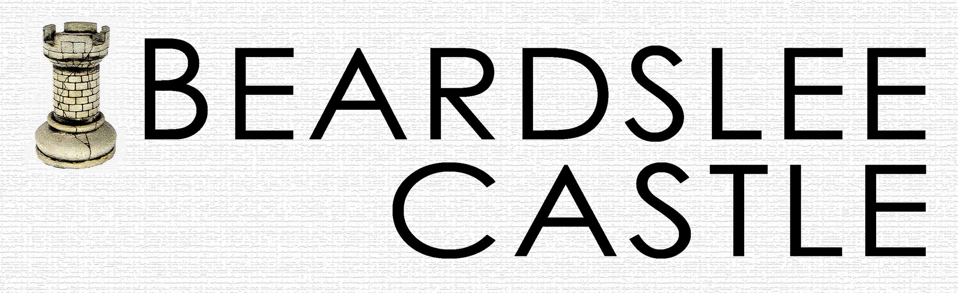

visit us at Beardslee castle.com or on Facebook

review us at tripadvisor and yelp

our menu changes daily, printed at the castle
entrees include
fresh baked breads with tapenade & humous & house salad

Bottled Water
Niagara Spring – Pa $1
Saratoga Sparkling 12oz $2.25
San Pellegrino Sparkling, Italy 1 liter $5
San Pellegrino Sparkling, Italy 500ml $2.75

BEER ON TAP –
please ask to see our 125 bottle beer list

Guinness Irish Stout 6./pint

Founder’s KBS 12.4% abv BA100 10./ 110oz
Kentucky Breakfast Stout, with a hint of coffee,
aged in bourbon barrels. very limited availability

Maine Beer Company Weez American Black Ale 7.2%abv 90BA 7. /10oz

New Belgium Brewing - Lips of Faith “La Folie”
Belgian Sour Brown Ale 94BA 7% abv 7. / 10oz

Westbrook White Thai Witbier with herbs 5% abv 7. /pint

Jack’s Abby Smoke & Dagger Rauchbier 5.8% abv 7. /pint

Bell’s Oberon wheat ae 5.8% abv 6. /pint

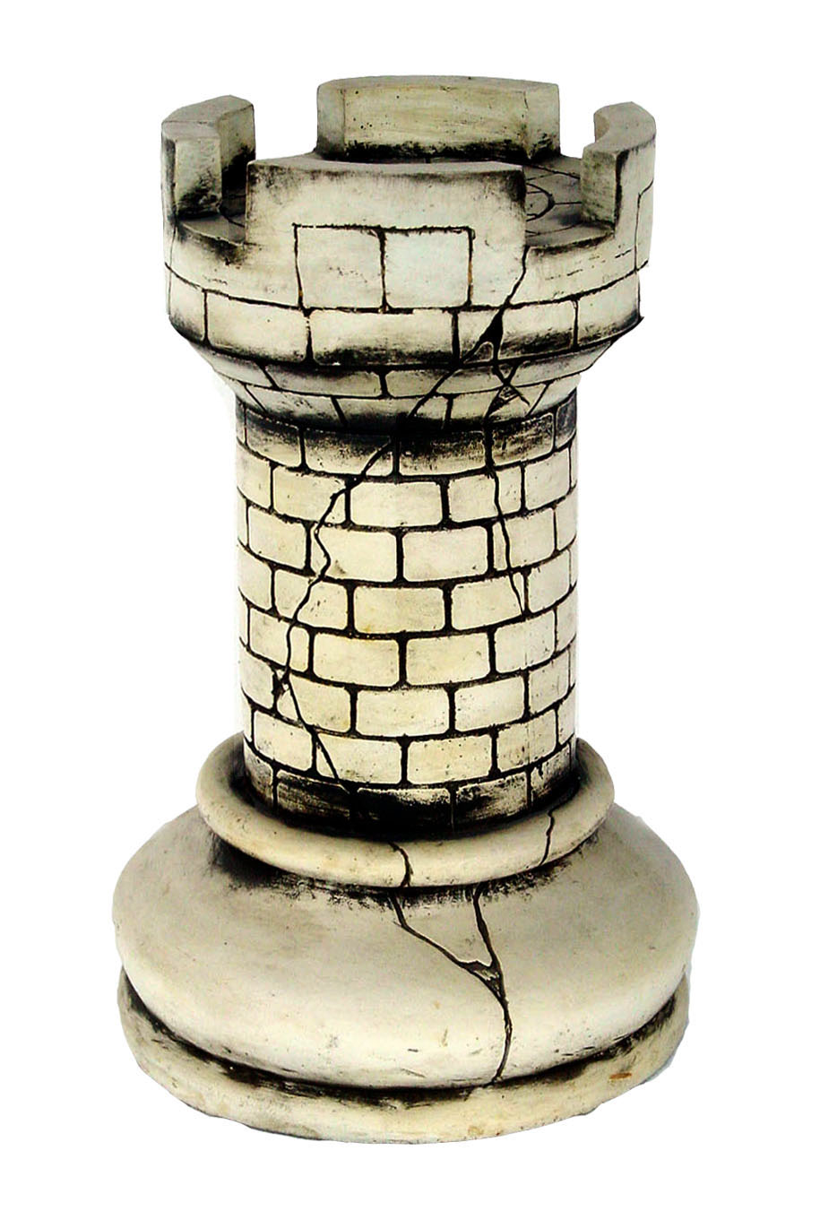
IMPORTANT NOTICE
REGARDING FOOD
ALLERGIES

While Beardslee Castle will
endeavor to accommodate
requests for special meals for
customers who have food allergies
or intolerances, we cannot guarantee
completely allergy-free meals

This is due to the potential of trace
elements in the working environment
and supplied ingredients

